**Project Initialization and Planning Phase**

| Date | 25 october 2025 |
| --- | --- |
| Team ID | SWUID20240103675 |
| Project Name | Power BI Inflation Analysis: Journeying Through Global Economic Terrain |
| Maximum Marks | 3 Marks |

**Define Problem Statements (Customer Problem Statement Template):**

Create a problem statement to understand your customer's point of view. The Customer Problem Statement template helps you focus on what matters to create experiences people will love. A well-articulated customer problem statement allows you and your team to find the ideal solution for your customers' challenges. Throughout the process, you’ll also be able to empathize with your customers, which helps you better understand how they perceive your product or service.

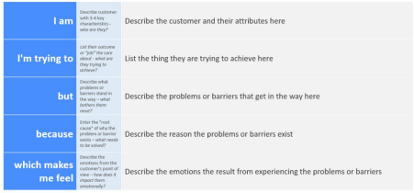

Reference: https://miro.com/templates/customer-problem-statement/

**Example:**



|  |  |  |  |  |  |
| --- | --- | --- | --- | --- | --- |
| **Problem**  **Statement (PS)** | **I am**  **(Customer)** | **I’m trying to** | **But** | **Because** | **Which makes me feel** |
| PS-1 | An analyst | Analyze how inflation varies globally | Data is spread across  multiple sources | There is no consolidated analytic dashboard to compare inflation trends across different countries | Frustrated, overwhelmed |
| PS-2 | A policymaker | Assess the impact of inflation on policy | Visualizations are complex and unclear | Making economic decisions without clear insights from inflation data is risky and ineffective | Uncertain, pressured |